**FATONI TRAVEL LIMITED PARTNERSHIP WEBSITE**

**HAJJ AND UMRAH WEBSITE FOR THAI PILGRIMS**

**ABDULHADI SASOR**

**621431017**

**MUHAMMAD BINHAJIMASMAN**

**621431008**

**REPORT FOR GATHERING REQUIREMENTS AND ANALYSIS, AND MAKING THE PROCESS OF REVERSE ENGINEERING, DATIL AND SPECIFICATION OF HAJJ AND UMRAH SERVICES WEBSITE APPLICATION**

**1444/2023**

**Title**: Fatoni Travel Limited

**Author**: MUHAMMAD BIN HAJMASAMAN 621431008.

ABDULHADI SASOR 621431017.

**Department:** INFORMATION TECHNOLOGY.

**Academic year:** 2023.

**Advisor: MR.FAUZAN** MAPA

# ABSTRACT

Fatoni University has approved the students to work for cooperative. Between 13 Dec 2022 till 13 Mar 2023, in the position of cooperative education student at Fatoni Travel Limited Partnership, the company’s main service is made booking travels for Hajj & Umrah and collecting information from the travelers who want to do Hajj & Umrah adding Date and Plans when to have flight where to stay in Makkah or Madinah with Tokseh who has more than 30 years of experience living in Kingdom of Saudi Arabia for responsibility for the travelers booked with the company. The company assigned for website to preview packages and information and some details about the services to contact more easily with employees

# ACKNOWLEDGMENT

We glad to have the opportunity to work in cooperative Fatoni Travel Limited Partnership since 13 Dec 2022 till 13 Mar 2023 was accomplished, our appreciation and gratitude to the kindness of consultants and employees. Other people in the workplace and outside the workplace educative as well as valuable advice to bring applied to make reports and develop the website it also provides suggestions and guidelines for conducting reports. After getting accurate reporting results, we gained the knowledge of adaptations to work in workplace.

Entrepreneurship working with others including gaining various experiences in addition to studying by this work would not have been possible without the personnel within Fatoni Travel Limited Partnership to provide advice, as well as providing new knowledge on working and adapting to the environment of workplace within the organization appropriately, which has received cooperation and support from various personnel in the organization as follows:

- MR. FAUZI LOHLEH Deputy Project Manager

- MR. MAHAMMASHUKRI YISAMA-AE Administrator

- MRS. SITI FATIMOH AMAE Hajj Officer

- MRS. NUBSOH KAEWSAM Hajj officer

Including all other people not mentioned by name who gave advice and assistance in preparing the report. We would like to thank Fatoni Travel Limited Partnership for the support and accepting cooperative education students. Cooperative Education and generous with knowledge, place, experience, as well as giving care and understanding about real working life throughout this cooperative education. Finally, if any mistakes occur the organizer would like to accept it and sincerely apologize on this occasion and the organizers sincerely hope that this Website report will be useful to who are interested.

# TABLE OF CONTEN

Contents

ABSTRACT 2

ACKNOWLEDGMENT 3

TABLE OF CONTEN 4

CHAPTER 1 INTRODUCTION 7

1.1 PROJECT OVERVIEW 7

1.2 PROBLEM STATEMENT 7

OBJECTIVE 8

1.4 PROJECT SCOPE 8

1.5 PROJECT SIGNIFICANT 8

**1.5.1 User** 8

**1.5.2 Developer** 8

1.6 HARDWARE AND SOFTWARE 9

1.6.1 Software requirements 9

1.6.2 Hardware requirement 9

CHAPTER 2 LITRATURE REVIEW 10

2.7 DEFINITIONS 10

**2.7.1 Tour packages** 10

**2.7.2 About Hajj** 10

**2.7.3 About Umrah** 11

2.2 TOOLS USED IN THIS PROJECT 12

**2.2.1 PHP** 12

**2.2.3 MYSQL DATABASE** 12

**2.2.4 XAMPP** 12

**2.2.5 LARAVEL** 13

**2.26 CSS** 13

**2.2.7 VIRTUAL STUDIO CODE** 14

**2.2.8 JAVASCRIPT** 14

**2.2.9 MYSQL WORKBENCH** 14

**2.2.10 SOURCE CONTROL(GITHUB)** 15

CHAPTER 3 16

METHODOLOGY 16

3.1 SOFTWARE DEVELOPMENT LIFE CYCLE 16

**3.1.1 SDLC Phases:** 17

**3.1.2 Agile** 17

**3.1.3 Phases of Agile Model:** 17

3.2 PLANNING 18

**3.2.1. ANALAYSIS** 18

3.3 LIST OF REQUIREMENTS 21

3.4 USE CASE DIAGRM 25

3.5 SEQUENCE DIAGRM 26

3.6 ACTIVITY DIAGRAM 30

3.7 WEBSITE INTERFACE 3.7.1 Registration interface 34

3.7.2 Homepage interface 35

3.7.3 Package Managing interface 36

CHAPTER 4 37

4.1.1 Face HTML of YOSR 37

CHAPTER 5 38

5.1 INTRODUCTION 38

5.2 LIMITAION 38

5.3 RECOMMAND AND FUTURE WORK 39

SUMMRY 39

**FATONI TRAVEL LIMITED PARTNERSHIP WEBSITE**

**HAJJ AND UMRAH WEBSITE FOR THAI PILGRIMS**

ABDULHADI SASOR

621431017

MUHAMMAD BINHAJIMASMAN

621431008

Report for gathering requirements and analysis, and making the process of reverse engineering, detail and specification of Hajj and Umrah services website application

**1444/2023**

# CHAPTER 1 INTRODUCTION

## 1.1 PROJECT OVERVIEW

Hajj and Umrah are two of the main aspects of Islam. Hajj is the last pillar of Islam's 5 pillars, and Muslims are required to do it if they have the ability to do. but at the other hand, Umrah is a lesser form of Hajj that consists of tasks that take place only at Masjid AL-Haram and can be finished in one day. The developed website made to help make the possibility of Hajj and Umrah easier to achieve, Hajj and Umrah contains sequences of steps and progressions, progressing from Mina to Arafat, staying in Muzdalifah collecting pebbles, returning to Mina to throw small stones at Jamarat, and farewell Tawaf.

Before performing Hajj and Umrah, there is processes, such as booking airlines, determining when and where the pilgrim should depart and land, and, due to cultural differences between Thailand and Saudi Arabia. All of these sequences of steps must be monitored and solved, and must be made and processed in a timely manner.

In this era of technology, there is a lot of development and expansion for the better, which means there are a lot of changes that need to be made. The traditional way of processing pilgrim data and information, which uses paper, is a thing of the past; we need new ways to complete our tasks, and we need to use technology to complete the pilgrim's ritual.

## 1.2 PROBLEM STATEMENT

As any pilgrim anywhere in the world knows, the process of Hajj and Umrah is fraught with problems, such as booking flights, calculating out where to start and when to begin, and need guidelines and instructional tools for pilgrims to follow in order to avoid getting lost, keeping track of time and specific dates related to Hajj and Umrah, and keeping on top about your own pilgrim’s society, and that is why Islam accepts and forgives those who are unable to perform it (citation). The issues here in Thailand include that there is no website or app that makes the Hajj and Umrah process, as well as any problems or difficulties that may arise.

## OBJECTIVE

This project is to make somethings more convenient:

* To analyze and design Fatoni travel limited partnership for Hajj and Umrah web application
* To develop Fatoni travel limited partnership for Hajj and Umrah web application
* To develop Packages and plans preview platform within Fatoni travel limited partnership for Hajj and Umrah web application

## 1.4 PROJECT SCOPE

This project will develop as Web website and has Three languages such as (English, Thai) for that point it will present to Crew (Tokseh), Staff (agent, employee) that work in company. Application will preview Packages that allow pilgrims to Hajj and Umrah The project targeting the crews (Tokseh)who can reach people want to do Hajj and Umrah. making platform that can have contact between Saudi Arabia and Thailand to made Fatoni travel limited partnership for the pilgrims. Allowing crews and Mutawif (Leader of providing Hajj and Umrah in Saudi Arabia) to have information about pilgrims. Make platforms for pilgrims who visit the website to preview the information about hajj.

## 1.5 PROJECT SIGNIFICANT

### 1.5.1 User

* Save time and make booking much easier process, the user only needs to input email and some needed data.
* Can see the available plans and chooses what suits the users.
* Can see the transportation or hotels available in the 2 holy places Makkah and Madinah.
* Easier way to input information needed, the server will for sure save information received from the user.
* Ability to have connection with the staff they can help the pilgrims.

### 1.5.2 Developer

* Improve skill
* Improvement of web development skill which consist of back-end front end, and web developments platforms, and be more capable in solving web development problems
* Learn new things The developer will increase more web development knowledge hopefully and intermediate full stack developer.

## 1.6 HARDWARE AND SOFTWARE

## 1.6.1 Software requirements

|  |  |
| --- | --- |
| **Specification** | Asus Tuff |
| **OS** | Windows 10 |
| **CPU** | AMD Ryzen 5 3550H with Radeon Vega Mobile Gfx 2.10 GHz |
| **Display** | (1920 x 1080) AMD Radon  Vega 8 graphics |
| **Memory** | 16.0 GB 2400MHz DDR2 |
| **Storage** | HDD Toshiba 1 Tera  SSD Samsung 239 GB |
| **Network interface** | Realtek 8822BE Wireless LAN 802.11ac PCI-E NIC  Bluetooth 10.0 personal area network |

|  |  |
| --- | --- |
| **Software** | **Version** |
| Xampp |  |
| PHP | 7.2.5 | 8.0 |
| MySQL | 10.1.37 |
| JavaScript |  |
| Bootstrap | 4.6.0 |
| Git | 2.32.0 |
| Laravel | 6.20 |
| VS code | 1.60.2 |
| Adobe XD |  |

## 1.6.2 Hardware requirement

# CHAPTER 2 LITRATURE REVIEW

## 2.7 DEFINITIONS

### 2.7.1 Tour packages

A package tour, package vacation, or package holiday, comprises transport and accommodation advertised and sold together by a vendor known as a tour operator. Other services may be provided such a rental car, booking hotels, tour into attracted places, and other activities during a holiday or a specific day or week or month. Transport be via automobile, buses, charter airline, and may also include travel between areas as part of the holiday. Package holidays are a form of product bundling.

Package holidays are organized by a tour operator and sold to a consumer by a travel agent. Some travel agents are employees of tour operators, other are independent.   
*Package tour* (2021, October 3). Wikipedia. <https://en.wikipedia.org/wiki/Package_tour>

In this project our tour packages aren’t specifically for tourism, but specifically for religious, creed and beliefs purposes, for Hajj and Umrah and the tour operator is going to be what we call Tokseh, he’s going to be the leader and the operator of this tour.

### 2.7.2 About Hajj

The Hajj (Arabic: حج “Pilgrimage”; sometimes spelled hadj, hadji or haj in English) is an annual Islamic pilgrimage to Makkah, Saudi Arabia the holiest city for Muslims. Hajj is a mandatory religious duty for Muslims that must be carried out at least once in their lifetime by all adult Muslims who are physically and financially capable of undertaking the journey, and of supporting their family during their absence from home.

In Islamic terminology, Hajj is a pilgrimage made to the Kabbah, the “House of Allah” in the sacred city of Mecca in Saudi Arabia. It is one of the five pillars of Islam, alongside with Shahadah, Salat, Zakat, and Swam or fasting of Ramadan. The Hajj is a demonstration of the solidarity of the Muslims people, and their submission to Allah the word Hajj means “to attend a journey”, which connotes both the outward act of a journey and the inward act of intentions.

The rites of pilgrimage are performed over five to six days, extending from the 8th to the 12th or 13th of Dhul-Hijjah, the last month of the Islamic calendar. Because of the Islamic calendar is lunar and the Islamic year is about eleven days shorter than the Gregorian year, the date of hajj changes from year to year in Gregorian year.

The Hajj associated with the life of Islamic prophet Muhammad from the 7thh century AD, but the ritual of pilgrimage to Makkah is considered by Muslims to stretch back thousands of years to the time of Abraham. During Hajj, pilgrims join processions of millions of people, who simultaneously converge on Makkah for the week of the Hajj, and perform a series of rituals: each person walks counter-clockwise seven times around the Kabba( a cube-shaped building and the direction of prayer for Muslims), trots (walks briskly) back and forth between the hills of Safa and Marwah seven times, then drinks from the Zamzam well, goes to the plains of Mount Arafat to stand in vigil, spends a night in the plain of Muzdalifa, and performs symbolic stoning of the devil by throwing stones at three pillars. After the sacrifice of an animal (can be accomplished by using a voucher), the Pilgrims then are required to either shave or trim their heads (male) or trim the ends of their hair (female). A celebration of the three-day global festival of Eid Al-Adha proceeds thereafter. Muslims may also undertake an Umrah (Arabic: عُمرَة), or "lesser pilgrimage" to Mecca at other times of the year. However, the Umrah is not a substitute for the Hajj and Muslims are still obligated to perform the Hajj at some other point in their lifetime if they have the means to do so.[[15]](https://en.wikipedia.org/wiki/Hajj#cite_note-15)

According to the official published statistics between 2000 and 2019,[[16]](https://en.wikipedia.org/wiki/Hajj#cite_note-stats1-16)[[17]](https://en.wikipedia.org/wiki/Hajj#cite_note-RESA1997-17)[[18]](https://en.wikipedia.org/wiki/Hajj#cite_note-:5-18) the average number of attendees is 2,269,145 per year, in which 1,564,710 come from outside Saudi Arabia and 671,983 are local. The year 2012 marks the highest number of participants with 3,161,573.[[19]](https://en.wikipedia.org/wiki/Hajj#cite_note-:6-19)

### 2.7.3 About Umrah

The Umrah (Arabic: عمرة “to visit a populated place”) is an Islamic pilgrimage to Mecca (the holiest city for Muslim, located in Hejazi region of Saudi Arabia) that can be undertaken at any time of the year, in contrast to Hajj(“Pilgrimage”) which has specific dates according to the Islamic lunar calendar.

In accordance to the *Shariah* (Law of Islam). For both pilgrimages, a Muslim must first assume Ihram, a state of purification achieved by completing cleansing rituals, wearing the prescribed attire and abstaining from certain actions. This must be attained when reaching a Miqat, a principal boundary point in Makkah. Different conditions exist for air travelers, who must observe Ihram once entering a specific perimeter in the city.

Umrah requires Muslim to preform two key rituals, Tawaf and Sa’I. Tawaf is a circling round the Kabba. This then followed by Sa’I between Safa and Marawah in the great mosque of Makkah, a walk to commemorate Hagar’s search for water for her son and God’s mercy in answering prayers. Pilgrims conclude the pilgrimage with Halq, a partial or complete shortening of the hair.

Umrah is sometimes considered the “lesser pilgrimage” in that it is not compulsory, but is still highly recommended. It is generally able to be completed in a few hours, in comparison to Hajj, which takes a few days. It’s also not meant to be interpreted as a substitute for Hajj, however both are demonstrations of the solidarity of the Muslims people, and their submission to Allah.

## 2.2 TOOLS USED IN THIS PROJECT

### 2.2.1 PHP

Stands for "Hypertext Preprocessor." (It is a recursive acronym, if you can understand what that means.) PHP is an HTML-embedded Web scripting language. This means PHP code can be inserted into the HTML of a Web page. When a PHP page is accessed, the PHP code is read or "parsed" by the server the page resides on. The output from the PHP functions on the page are typically returned as HTML code, which can be read by the browser. Because the PHP code is transformed into HTML before the page is loaded, users cannot view the PHP code on a page. This makes PHP pages secure enough to access databases and other secure information. A lot of the syntax of PHP is borrowed from other languages such as C, Java and Perl. However, PHP has a number of unique features and specific functions as well. The goal of the language is to allow Web developers to write dynamically generated pages quickly and easily. PHP is also great for creating database-driven Web sites. (Techterms,2020)

### 2.2.3 MYSQL DATABASE

A MYSQL Database is a relational database that uses MySQL language to get the data. MYSQL database contains the data in table and relation between tables such as one to one (one data has refer one data in another table), one to many (one data has refer to many data in others table). (Christensson, P. 2009)

### 2.2.4 XAMPP

XAMPP is an abbreviation for cross-platform, Apache, MySQL, PHP and Perl, and it allows you to build WordPress site offline, on a local web server on your computer. This simple and lightweight solution works on Windows, Linux, and Mac – hence the “cross-platform” part. Since WordPress isn’t a stand-alone application, XAMPP provides two essential components for its installation – Apache, which is used to create the local server, and MySQL which you can use as a database for your website. You may be wondering why and how developers are using WordPress local server. The answer is simple – it allows them to create a local copy of the site in which they can try out new plugin updates before implementing them on its live version.

### 2.2.5 LARAVEL

Laravel is a web application framework with expressive, elegant syntax We believe development must be an enjoyable, creative experience to be truly fulfilling Laravel attempts to take the pain out of development by easing common tasks used in the majority of web projects, such as authentication, routing, sessions, and caching. Laravel aims to make the development process a pleasing one for the developer without sacrificing application functionality Happy developers make the best code. To this end, we've attempted to combine the very best of what we have seen in other web frameworks, including frameworks implemented in other languages, such as Ruby on Rails, ASP NET MVC, and Sinatra. Laravel is accessible, yet powerful, providing powerful tools needed for large, robust applications. A superb inversion of control container, expressive migration system, and tightly integrated unit testing support give you the tools you need to build any application with which you are tasked (Luravel,2019).

### 2.26 CSS

Stands for "Cascading Style Sheet." Cascading style sheets are used to format the layout of Web pages They can be used to define text styles, table sizes, and other aspects of Web pages that previously could only be defined in a page's HTMI, CSS helps Web developers create a uniform look across several pages of a Web site. Instead of defining the style of each table and cache block of text within a page's HTML, commonly used styles need to be defined only once in a CSS document. Once the style is defined in a cascading style sheet, it can be used by any page that references the CSS file Plus, CSS makes it easy to change styles across several pages at once for example, a Web developer may want to increase the default text size from 10pt to 12pt for fifty pages of a Web site. If the pages all reference the same style sheet, the text size only needs to be changed on the style sheet and all the pages will show the larger text. While CSS is great for creating text styles, it is helpful for formatting other aspects of Web page layout as well. For example, CSS can be used to define the cell padding of table cells, the style, thickness, and color of a table's border, and the padding around images or other objects. CSS gives Web developers more exact control over how Web pages will look than HTML does. This is why most Web pages today incorporate cascading style sheets. (Christensson, P 2006)

### 2.2.7 VIRTUAL STUDIO CODE

Visual Studio Code is a code editor redefined and optimized for building and debugging modern web and cloud applications. (Shukerullah,2018) Visual Studio Code is a cross-platform, free and open-source (licensed under the MIT License) text editor developed by Microsoft and written in JavaScript and TypeScript. It is built on the Electron framework and is extensible using extensions, which can be browsed from within the text editor itself (via its extension gallery). (Archlinux.2018)

### 2.2.8 JAVASCRIPT

JavaScript is a programming language commonly used in web development. It was originally developed by Netscape as a means to add dynamic and interactive elements to websites. While JavaScript is influenced by Java, the syntax is more similar to C and is based on ECMAScript, a scripting language developed by Sun Microsystems. JavaScript is a chent-side scripting language, which means the source code is processed by the client's web browser rather than on the web server This means JavaScript functions can run after a web page has loaded without communicating with the server For example, a JavaScript function may check a web form before it submitted to make sure all the required fields have been filled out The JavaScript code can produce an error message before any information is actually transmitted to the server Like server-side scripting languages, such as PHP and ASP, JavaScript code can be inserted anywhere within the HTML of a webpage. However, only the output of server-side code is displayed in the HTML, while JavaScript code remains fully visible in the source of the webpage. It can also be referenced in a separate JS file, which may also be viewed in a browser (Christensson, P 2014)

### 2.2.9 MYSQL WORKBENCH

MYSQL Workbench is a unified visual tool for database architects, developers, and DBAS. MYSQL Workbench provides data modeling, SQL development, and comprehensive administration tools for server configuration, user administration, backup, and much more. MYSQL Workbench is available on Windows, Linux and Mac OS X.(mysql,2019)

### 2.2.10 SOURCE CONTROL(GITHUB)

Source control (or version control) is the practice of tracking and managing changes to code. Source control management (SCM) systems provide a running history of code development and help to resolve conflicts when merging contributions from multiple sources. (Amazon, 2019) GitHub is a for-profit company that offers cloud-based Git repository hosting service. Essentially, it makes it a lot easier for individuals and teams to use Git for version control and collaboration. (Kinsta,2019)

# CHAPTER 3

# METHODOLOGY

## 3.1 SOFTWARE DEVELOPMENT LIFE CYCLE

The Software Development Life Cycle (SDLC) is the software development worlds spellcheck — it can flag errors in software creation before they’re discovered (at a much higher cost) in successive stages. But it’s much more than that, of course: SDLC can also lay out a plan for getting everything right the first time.

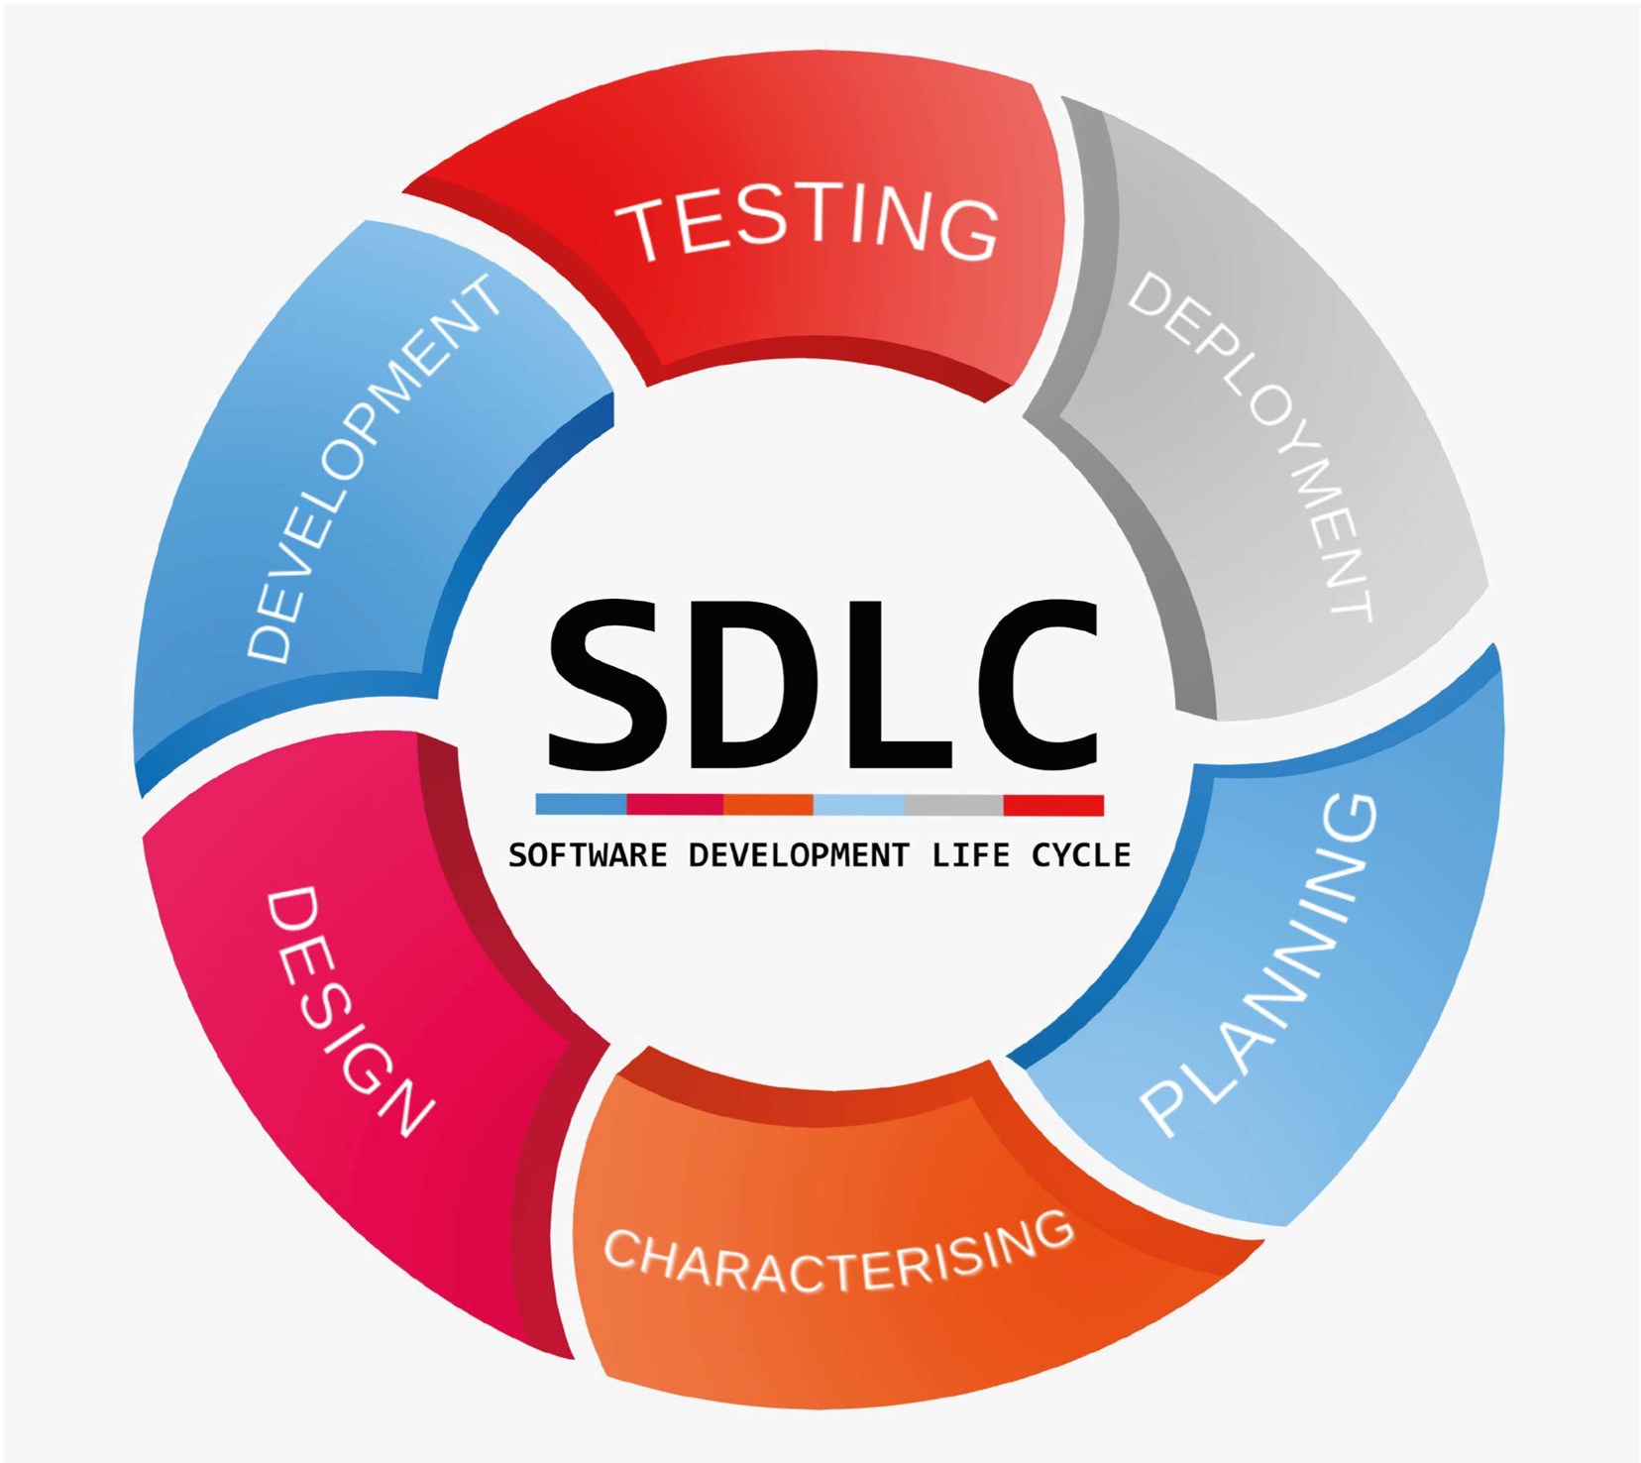The SDLC process involves several distinct stages, including planning, analysis, design, building, testing, deployment and maintenance. What’s the best SDLC methodology? Here are six methodologies, or models, to consider.

### Figure.3.1 SDLC Representation

### 3.1.1 SDLC Phases:

1. Planning
2. Analysis
3. Design
4. Implementation
5. Testing and Integration
6. 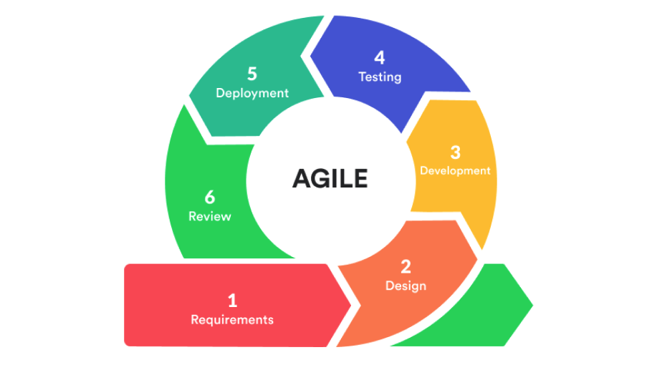Maintenance

### Figure.3.2 Agile Representation

### 3.1.2 Agile

The meaning of Agile is swift or versatile. “Agile process model" refers to a software development approach based on iterative development. Agile methods break tasks into smaller iterations, or parts do not directly involve long term planning. The project scope and requirements are laid down at the beginning of the development process. Plans regarding the number of iterations, the duration and the scope of each iteration are clearly defined in advance.

### 3.1.3 Phases of Agile Model:

Following are the phases in the Agile model are as follows:

1. Requirements gathering
2. Design the requirements
3. Construction/ iteration
4. Testing/ Quality assurance
5. Deployment
6. Feedback

## 3.2 PLANNING

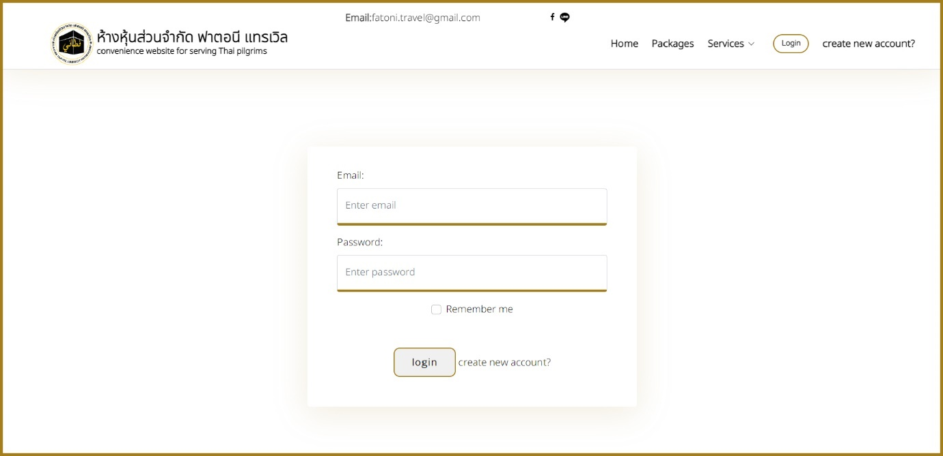

### Figure.3.3 FTLP login page

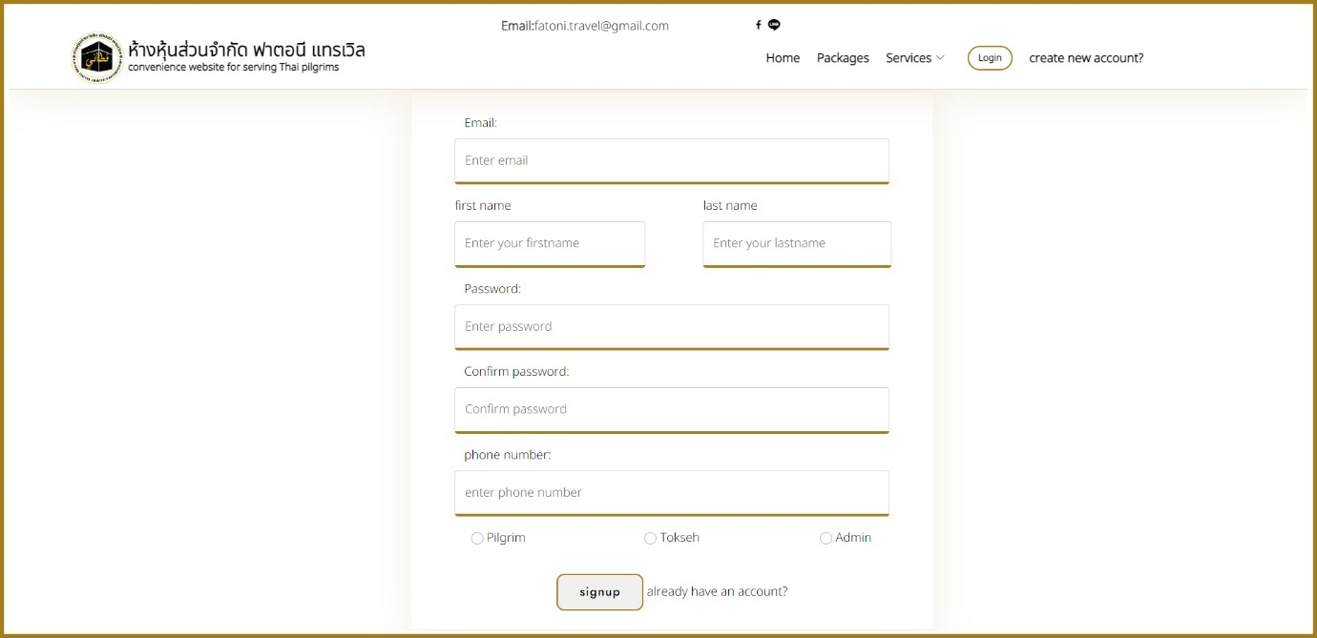

### Figure.3.4 FTLP register page

### Figure.3. FTLP home page

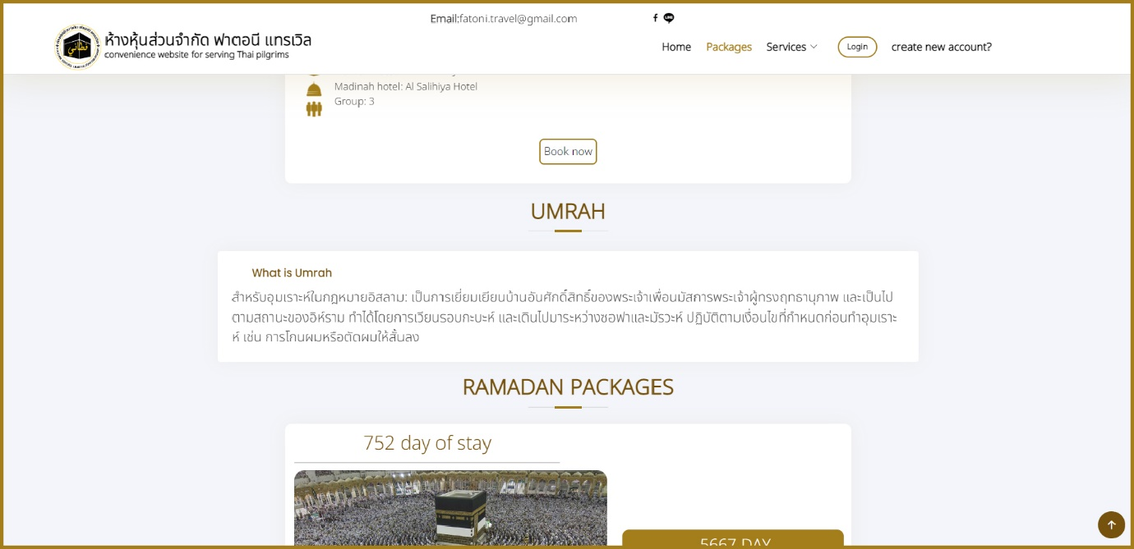

### Figure.3. 6 FTLP information form Figure.3. 7 FTLP about us form

## 3.3 LIST OF REQUIREMENTS

|  |  |  |  |
| --- | --- | --- | --- |
| **No.** | **Req _ ID** | **Requirement Description** | **Priority** |
|  | Req_01 | Sign in |  |
| 1 | Req_1.1 | Administrator can sign in | M |
| 2 | Req_1.2 | Crew (Tokseh) can sign in | M |
| 3 | Req_1.3 | User (Pilgrim) can sign in | O |
|  | Req_2 | Manage Packages |  |
| 4 | Req_2.1 | Admin can add packages | M |
| 5 | Req_2.2 | Admin can update packages | M |
| 6 | Req_2.3 | Admin can delete packages | M |
| 7 | Req_2.4 | Admin can view packages | M |
| 8 | Req_2.5 | Crew (Tokseh) choose suitable plans for their package | M |
| 9 | Req_3.6 | Crew (Tokseh) can contact with the provider of available flights | D |
| 10 | Req_3.7 | Crew (Tokseh) can contact with the provider of available hotels | D |
| 11 | Req_3.8 | Crew (Tokseh) choose suitable plans for their package | M |
|  | Req_3 | Manage package research |  |
| 8 | Req_3.1 | Admin can add package research |  |
| 9 | Req_3.2 | Admin can update package research |  |
| 10 | Req_3.3 | Admin can delete package research |  |
| 11 | Req_3.4 | Admin can view package research |  |
| 12 | Req_3.5 | Admin can search package research |  |
|  | Req_2.1 | Admin Provide platform that recommends where to get flights plans | M |
|  | Req_2.2 | Admin Provide platform that recommends where to get hotels | M |
|  | Req_2.3 | Crew (Tokseh) can add his own flights plan from his own research, not provided by the admin | M |
|  | Req_2.4 | Crew (Tokseh) can add his own hotels plan from his own research, not provided by the admin | M |
|  | Req_4 | Manage preview package |  |
| 13 | Req_4.1 | Admin can create preview package | M |
| 14 | Req_4.2 | Admin can update preview package | M |
| 15 | Req_4.3 | Admin can delete preview package | M |
| 16 | Req_4.4 | Admin can view preview package | M |
| 17 | Req_4.5 | Crew can create preview package | M |
| 18 | Req_4.6 | Crew can update preview package | M |
| 19 | Req_4.7 | Crew can delete preview package | M |
| 20 | Req_4.8 | Crew can view preview package | M |
| 21 | Req_4.9 | User (Pilgrim) can add suitable package for them | M |
| 22 | Req_4.10 | User(pilgrim) can look up for specific hotel where it displays which Tokseh have it in their own plan or package | D |
| 23 | Req_4.11 | User(pilgrim) can look up for specific flights where it displays which Tokseh have it in their own plan or package | D |
| 24 | Req_4.12 | User(pilgrim) can create their own custom plan and recommend it to the Tokseh platform |  |
| 25 | Req_4.13 | User can book package |  |
| 26 | Req_4.14 | User can update and change package |  |
| 27 | Req_4.15 | User can delete package |  |
|  | Req_5 | Manage pilgrim |  |
| 21 | Req_5.1 | Admin can add pilgrim | M |
| 22 | Req_5.2 | Admin can update pilgrim | M |
| 23 | Req_5.3 | Admin can delete pilgrim | M |
| 24 | Req_5.4 | Admin can view pilgrim | M |
| 25 | Req_5.5 | Crew can add pilgrim | M |
| 26 | Req_5.6 | Crew can update pilgrim | M |
| 27 | Req_5.7 | Crew can delete pilgrim | M |
| 28 | Req_5.8 | Crew can view pilgrim | M |
|  | Req_6 | Manage recommend pilgrims package |  |
| 29 | Req_6.1 | Admin can add command pilgrim |  |
| 30 | Req_6.2 | Admin can update command pilgrim |  |
| 31 | Req_6.3 | Admin can delete command pilgrim |  |
| 32 | Req_6.4 | Admin can view pilgrim |  |
| 33 | Req_6.5 | Crew can add command pilgrim |  |
| 34 | Req_6.6 | Crew can update command pilgrim |  |
| 35 | Req_6.7 | Crew can delete command pilgrim |  |
| 36 | Req_6.8 | Crew can view command pilgrim |  |
|  | Req_7 | View report |  |
| 37 | Req_7.1 | Admin can view report |  |
|  | Req_8 | Manage crew |  |
| 38 | Req_8.1 | Admin can add crew |  |
| 39 | Req_8.2 | Admin can update crew |  |
| 40 | Req_8.3 | Admin can delete crew |  |
| 41 | Req_8.4 | Admin can crew |  |
|  | Req_9 | Manage preview order |  |
| 42 | Req_9.1 | Admin can add order |  |
| 43 | Req_9.2 | Admin can update order |  |
| 44 | Req_9.3 | Admin can delete order |  |
| 45 | Req_9.4 | Admin can view order |  |
| 46 | Req_9.5 | (User)Pilgrim can add order |  |
| 47 | Req_9.6 | (User)pilgrim can update order |  |
| 48 | Req_9.7 | (User)Pilgrim can delete order |  |
| 49 | Req_9.8 | (User)pilgrim can view order |  |
|  | Req_10 | Manage pilgrims Stats |  |
| 50 | Req_10.1 | Admin can add pilgrims Stats |  |
| 51 | Req_10.2 | Admin can view pilgrims Stats |  |
| 52 | Req_10.3 | Admin can delete pilgrims Stats |  |
| 53 | Req_10.4 | Admin can update pilgrims Stats |  |
| 54 | Req_10.5 | Crew can add pilgrims Stats |  |
| 55 | Req_10.6 | Crew can view pilgrims Stats |  |
| 56 | Req_10.7 | Crew can delete pilgrims Stats |  |
| 57 | Req_10.8 | Crew can update pilgrims Stats |  |

## 3.4 USE CASE DIAGRM

This diagram will explain about relationship between actors and application and also permission that actors can access to the function of application. Belong to figure Administrator can be access to function Mange Packages, Manage Packages category, access to manage order and all function can access after user sign in.

### Figure.3. 7 FTLP Use case diagram

## 3.5 SEQUENCE DIAGRM

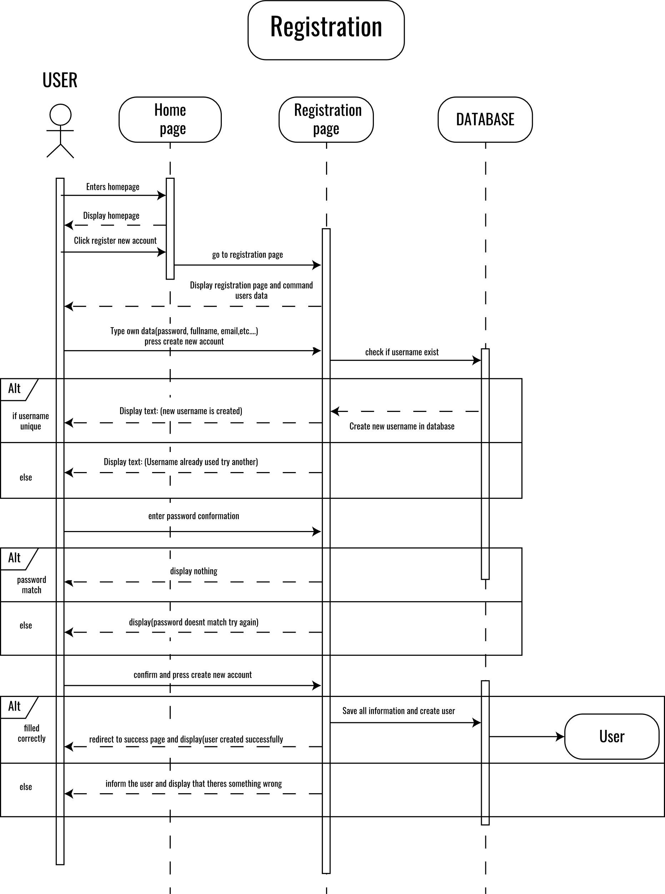Sequence diagram describes how groups of objects collaborate in some behavior. The UML defines several forms of interaction diagram. Developer use sequence diagrams when developer wants to look at the behavior of several objects within a single use

### Figure.3. 8 FTLP Register Sequence

### Figure.3. 9 FTLP Login sequence

### Figure.3. 10 FTLP Package Sequence

## 

## 3.6 ACTIVITY DIAGRAM

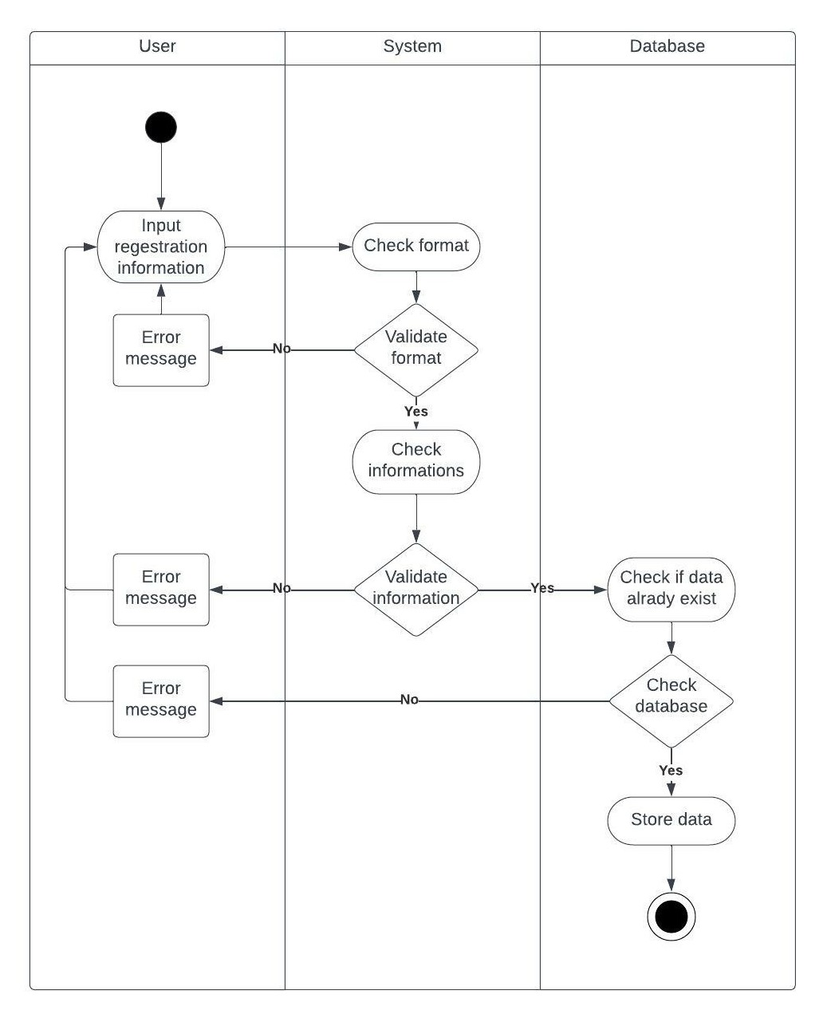Activity diagrams are a technique to describe procedural logic, business process, and work flow. In many ways, they play a role similar to flowcharts, but the principal difference between them and flowchart notation is that they support parallel behaviour. notation is that they support parallel behaviour.

### Figure.3. 11 FTLP Registration Activity

## 3.6. Logging Activity

### Figure.3. 12 FTLP Login Activity

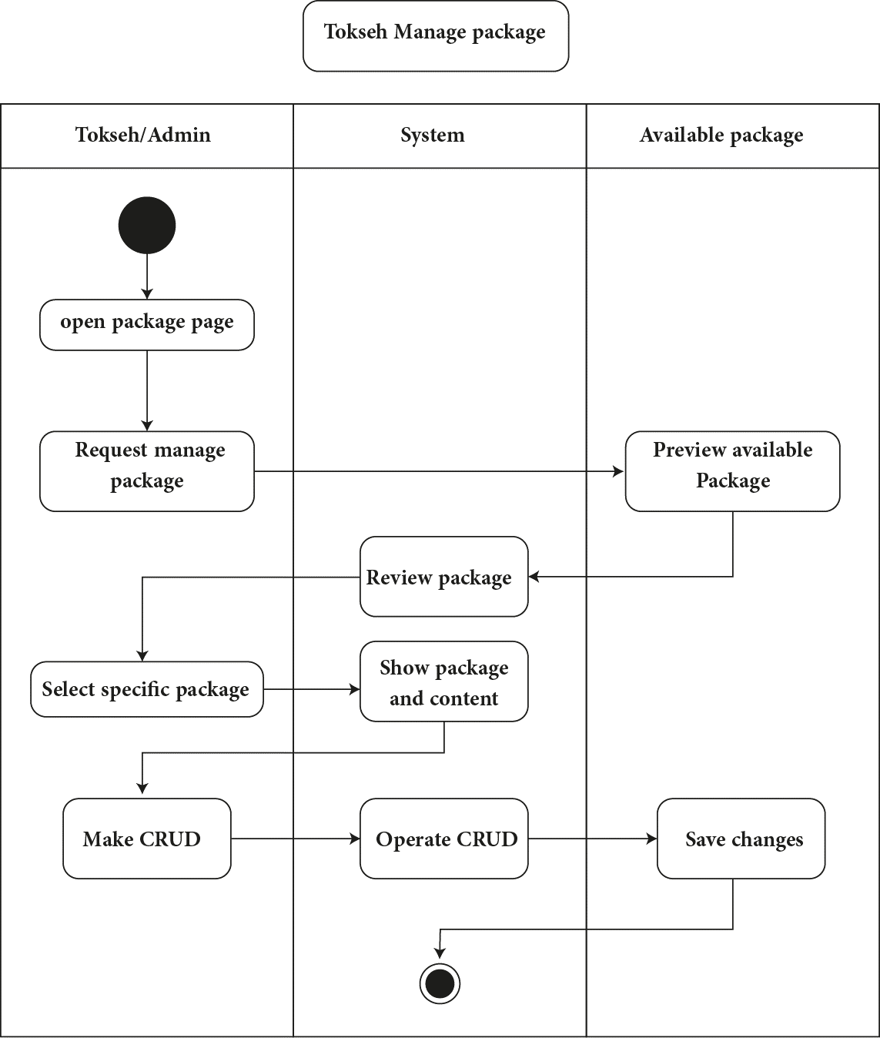

### Figure.3. 13 FTLP Package page Activity

# CHAPTER 4

## 4.1.1 Face HTML of Fatoni Travel Limited Partnership

### Figure.4. 1 FTLP Login HTML



### Figure.4. 2 FTLP Register HTML

### Figure.4. 3 FTLP Main home page

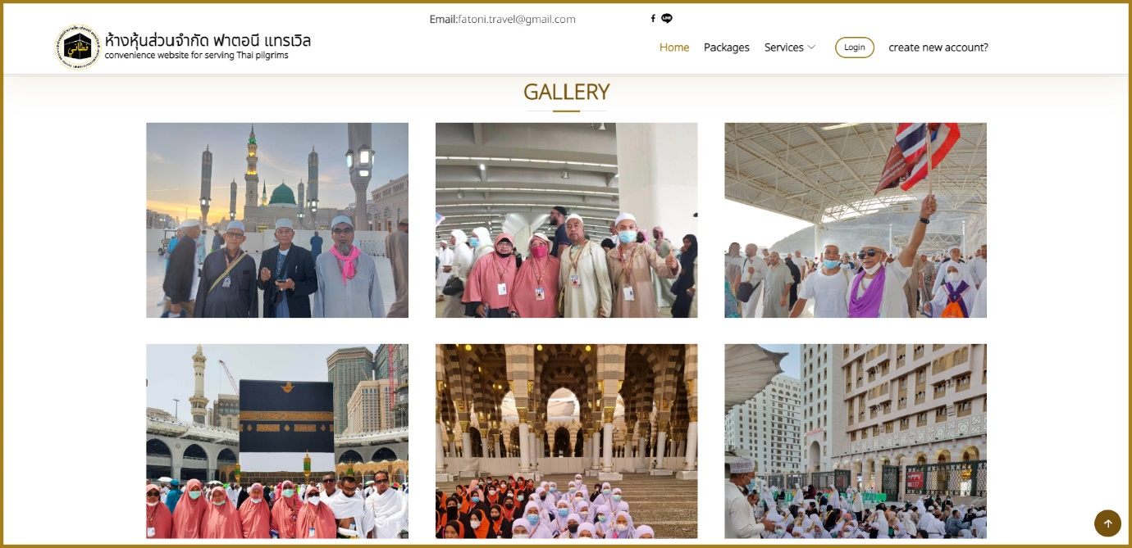

### Figure.4. 4 FTLP Gallery

### Figure.4. 5 FTLP Home Hajj packages

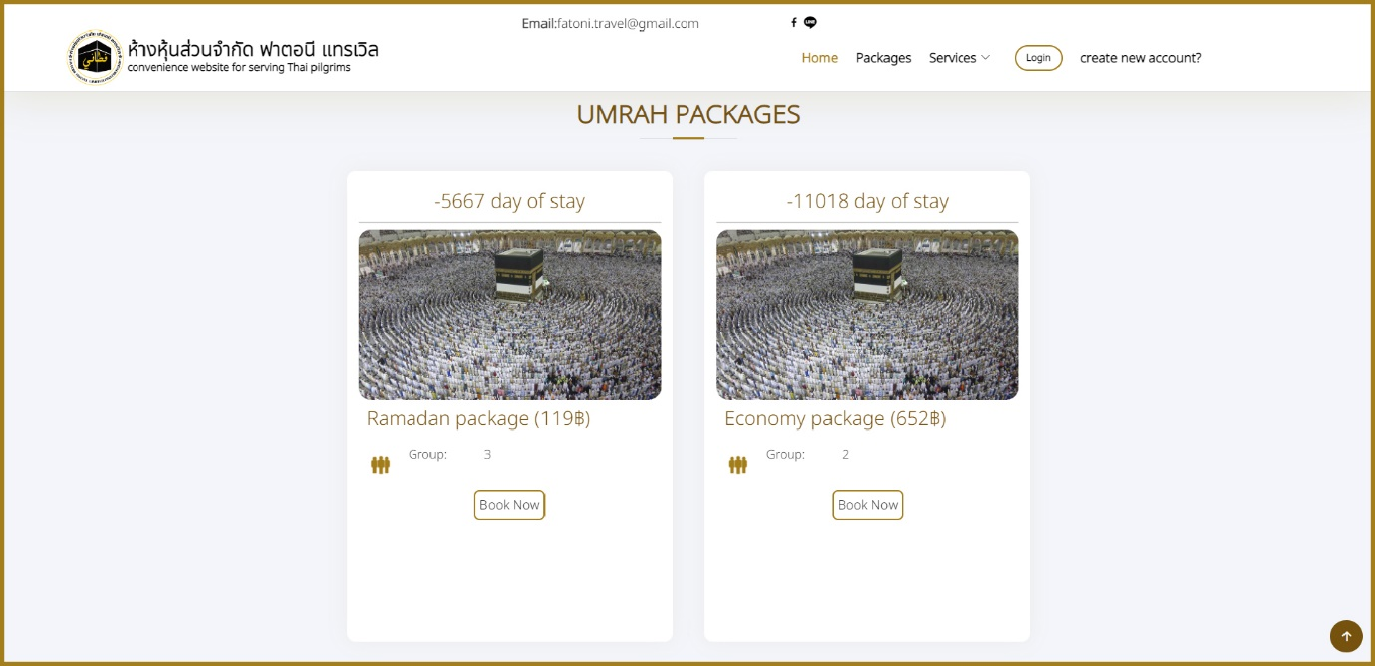

### Figure.4. 6 FTLP Home Umrah packages

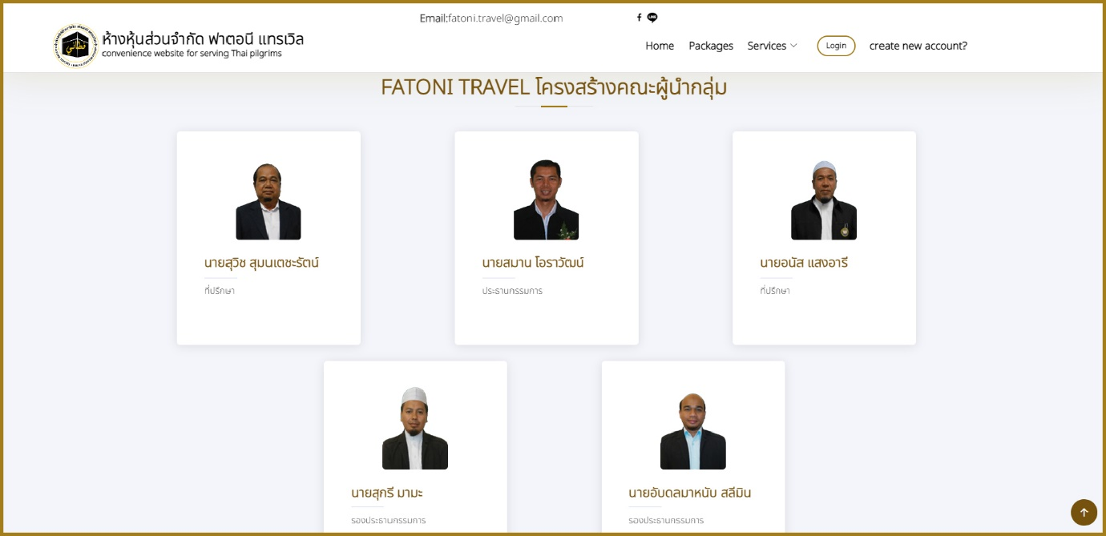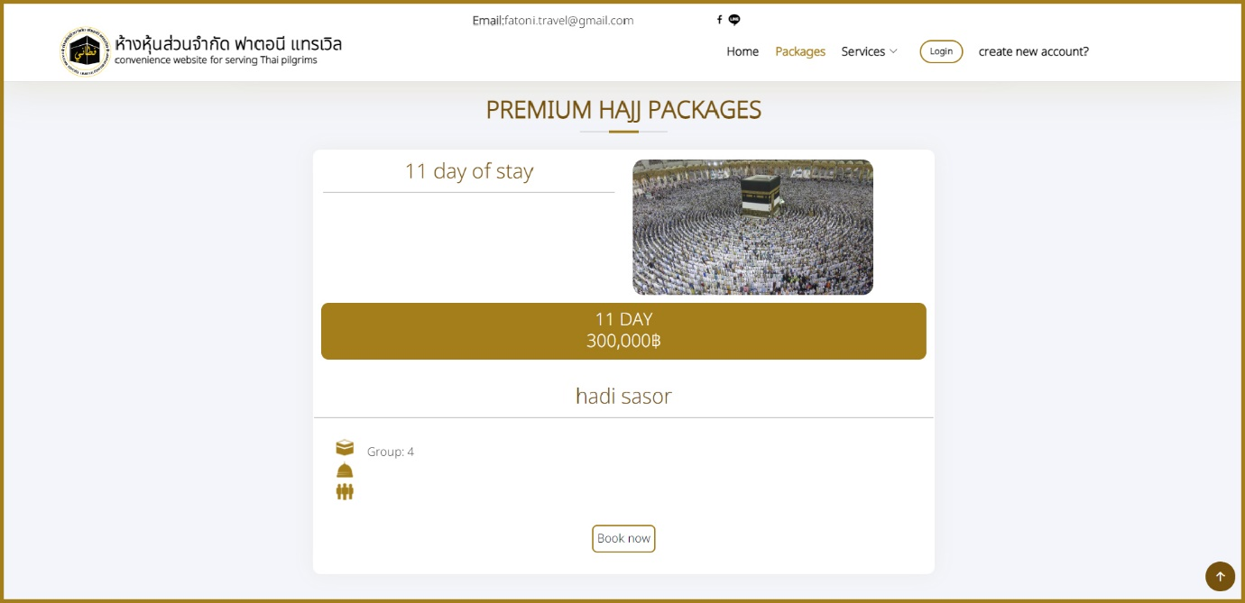

### Figure.4. 7 FTLP Packages form

### Figure.4. 1 FTLP Employee info card

# CHAPTER 5

## 5.1 INTRODUCTION

This project provides an overview of Hajj & Umrah showing packages by making a Website for Pilgrims. Project objectives has been defined, moreover scope of the design Fatoni Travel Limited Partnership for Hajj and Umrah web application, developing Packages and plans preview platform within Fatoni Travel Limited Partnership for Hajj and Umrah web application.

## 5.3 RECOMMAND AND FUTURE WORK

Generally, this Web application style preview packages for pilgrims and purchase for doing Hajj and Umrah still not perfect, it needs more improvements, The developer suggests and recommend as follows:

* Add more feature to let users use this application more satisfied.
* Multi language
* The application uses only English language, the multi-language can increase the target of user and interest for use.
* Running in Android and IOS

The application can be converted as app in Mobiles for increase the target of users.

## SUMMRY

Hajj & Umrah packages named as Fatoni Travel Limited Partnership developed for tokseh making packages for pilgrims

The benefit of this application is to satisfied pilgrims for doing Hajj & Umrah and know the schedule of doing Hajj & Umrah

**APPENDIX**

1. Gant Chart

|  |  |  |  |  |  |  |  |  |
| --- | --- | --- | --- | --- | --- | --- | --- | --- |
| **No** | **Tasks/**  **Dates** | **December** | | | **January** | | | |
| 12 to 16 | 19 to 23 | 26 to 30 | 2 to 6 | 9 to 13 | 16 to 20 | 23 to 27 |
| 1 | Home page |  |  |  |  |  |  |  |
|  |  |  |  |  |  |  |
| 2 | Login page |  |  |  |  |  |  |  |
| 3 | Register page |  |  |  |  |  |  |  |
| 4 | Services |  |  |  |  |  |  |  |
| 5 | Admin page |  |  |  |  |  |  |  |
| 6 | Dashboard |  |  |  |  |  |  |  |

|  |  |  |  |  |  |  |  |
| --- | --- | --- | --- | --- | --- | --- | --- |
| **No** | **Tasks/**  **Dates** | **February** | | | | **March** | |
| 30 to 3 | 6 to 10 | 13 to 17 | 20 to 24 | 27 to 3 | 6 to 10 |
| 7 | Building tables in Database |  |  |  |  |  |  |
| 8 | Hajj/Umrah Packages |  |  |  |  |  |  |
| 9 | Photo edit preview |  |  |  |  |  |  |
| 10 | Present progress |  |  |  |  |  |  |
| 11 | Re design all pages |  |  |  |  |  |
| 12 | Writing Project proposal |  |  |  |  |  |
| 13 | Editing information in project |  |  |  |  |  |  |
| 14 | Final presentation |  |  |  |  |  |  |

1. User’s Manual

